Steps to setup BnC storefront in local box

1. The machine should have JDK 7 version: jdk1.7.0_XX (for e.g. jdk-7u45-windows-x64)
2. Download and Unpack hybris Packages
3. Go to the <https://wiki.hybris.com/display/downloads/Download>  page and download the packages you want to install. For downloading hybris suite, use following url: <https://download.hybris.com/resources/releases/5.1.0/hybris-commerce-suite-5.1.0.0.zip> This will contain the complete hybris suite including hybris (all the accelerators), OMS, hybris-Mobile-Apps-SDK, etc.
4. Create the directory where you will extract the ZIP archives. This directory must meet the following conditions:

* It must be close to the system root directory (for example C:\hybris. You may download the files directly to the root directory, because the ZIP files already contain directory hybris). Microsoft Windows requires the directory paths to be shorter than 255 characters long. Any part of a directory path exceeding this limitation is truncated. The hybris Commerce Suite modules installation creates several sub-directories — therefore use short directory paths in the first place.
* Do not use directory paths containing spaces (such as C:\hybris Platform). Building the hybris Commerce Suite fails if the directory path contains spaces.
* When extracting a zip file on Windows, you may encounter an error due to path length. You may receive an error message similar to "Cannot create <pathname> total path and file name length must exceed 260 characters". If so, you can:
  + Use an alternative extraction tool, one that does not limit the path or name size.
  + Enter the following command in the command line: execute "jar -xvf <zipfilename>".

1. Extract the ZIP archives into the created directory. After the installation has been completed, the chosen directory should contain the structure similar to the example below:

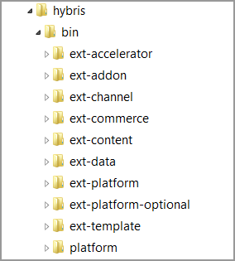

1. Build the hybris Commerce Suite

After all the files have been successfully downloaded and unpacked, you must build and adapt the hybris Commerce Suite before use.

To build hybris Commerce Suite, perform the following steps:

1. Set Up Apache Ant.

* Open a command prompt in Microsoft Windows (shell in Unix family systems).
* Navigate to the ${HYBRIS_BIN_DIR}/platform directory, for example:C:\hybris\bin\platform.
* Run the setantenv file that matches your operating system. The result looks similar to this:

*C:\hybris\bin\platform>setantenv.bat*

*Setting ant home to: C:\hybris-5.1\hybris\bin\platform\apache-ant-1.8.2*

*Apache Ant(TM) version 1.8.2 compiled on March 20 2014*

1. Build the hybris Commerce Suite.

* Go to the Windows command prompt (shell in Unix family systems), navigate to the ${HYBRIS_BIN_DIR}/platform directory and type ant clean all.
* The application build process now prompts you to specify a configuration template for your operation environment: development or production. The default option is development. For implementation purposes, you typically use the default configuration template (develop) by pressing the Enter key.
* This will build the hybris suite and will create the all the necessary folders shown in following screenshot.

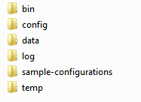

After you have successfully built the hybris Commerce Suite, you will find the /config directory. The factory default location is${platformhome}/../../config. It contains localextensions.xml, local.properties files and other folders as shown in following screenshot.

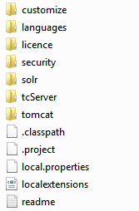

1. Now take this attached code.zip file and extract to a specific location. 
2. Take the custom folder from the extracted folder and paste in bin folder. \hybris\bin
3. Take the localextensions.xml and local.properties file form extracted config folder and paste them under config folder (${platformhome}/../../config).
4. Navigate to hybris\bin\ext-template\yb2bacceleratorcore

And open extensioninfo.xml and comment following line

*<!-- <requires-extension name="yacceleratorfulfilmentprocess" />-->*

Please add below line after commenting yacceleratorfulfilmentprocess

*<requires-extension name="bncfulfilmentprocess" />*

1. Now perform ant clean all command. This will build the entire project once again including BnC extensions.
2. Now perform following command to include and build b2ccheckoutaddon in the project.

*ant addoninstall -Daddonnames="b2ccheckoutaddon" -DaddonStorefront.yacceleratorstorefront="bncstorefront"*

1. Setup this project in Eclipse including all the OOB extensions, platform, config.
2. Search for following entry in impex files.

*/yacceleratorcore/*

This will give result as following:

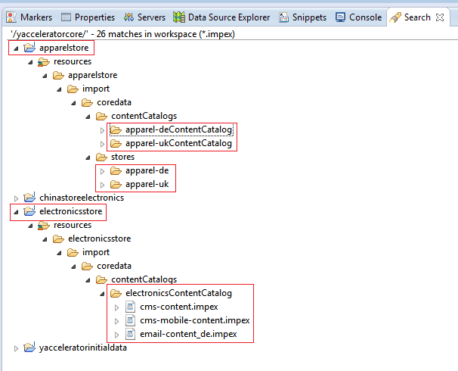

Now perform following actions for apparelstore and electronic store extensions:

|  |  |  |
| --- | --- | --- |
| # | Text to be commented | Text to be added |
| 1 | $jarResourceCms=jar:de.hybris.platform.yacceleratorcore.setup.CoreSystemSetup&/yacceleratorcore/import/cockpits/cmscockpit | $jarResourceCms=jar:com.acc.core.setup.CoreSystemSetup&/bnccore/import/cockpits/cmscockpit |
| 2 | $emailPackageName=de.hybris.platform.yacceleratorfacades.process.email.context | $emailPackageName=com.acc.facades.process.email.context |
| 3 | $jarResource=jar:de.hybris.platform.yacceleratorcore.setup.CoreSystemSetup&/yacceleratorcore/import/common/ | $jarResource=jar:com.acc.core.setup.CoreSystemSetup&/bnccore/import/common/ |
| 4 | $emailResource=jar:de.hybris.platform.yacceleratorcore.setup.CoreSystemSetup&/yacceleratorcore/import/emails | $emailResource=jar:com.acc.core.setup.CoreSystemSetup&/bnccore/import/emails |

1. Once these changes are done, then perform ant all command.
2. Once the build is successful, start the hybris server using *hybrisserver.bat* command
3. Once the hybris server is started, then system initialization is required.

Initialize the hybris Commerce Suite

To finish the installation, you have to initialize the hybris Commerce Suite. During the initialization, the database tables, the type system, and the mandatory system data are created.

1. Open the hybris Administration Console. The default URL for the hAC is http://localhost:9001.
2. You are prompted to enter a user account and a password.  
   By factory default, you can use the **admin**user account and the **nimda** password.

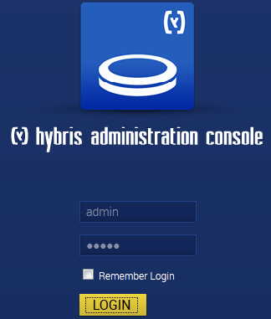

1. Go to the Platform tab and select Initialization option.



1. The Initialization page opens with preconfigured settings for initialization.
2. Without changing any settings, click the Initialize button. The initialization process starts and can take several minutes.
3. Once initialization is completed, click on continue button.
4. Navigate to \hybris\bin\custom\bnc\bncinitialdata\resources\bncinitialdata\import\coredata\contentCatalogs\catalogName

Now execute following impexes located at this path in the below order through hAC:

* bnc-content.impex
* electronicsSite-logo.impex
* apparelUKSite-logo.impex
* apparelDESite-logo.impex
* powertoolsSite-logo.impex

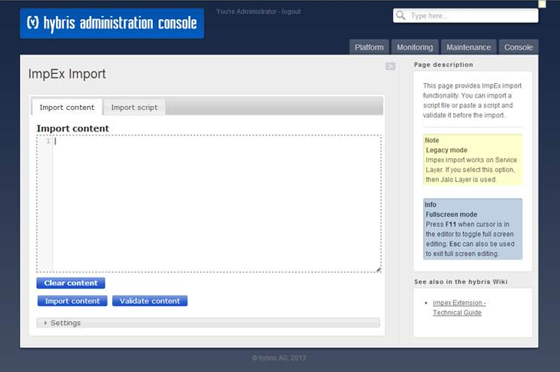

1. hMC (hybris management console) can be accessed via <http://localhost:9001/hmc/hybris> with username as admin and password as nimda.
2. Once all the impexes are executed successfully, perform synchronization for all the catalogs through hMC.

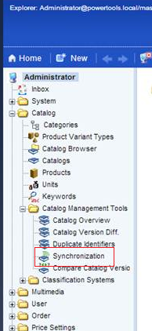

The sync job needs to be executed for all the catalogs (electronics, apparel-uk, apparel-de, powertools) for staged to Online data movement. This has to be done for both Product and Content Catalogs.

1. Take the attached CSS file .

And paste it under \hybris\bin\ext-template\yb2bacceleratorstorefront\web\webroot\_ui\desktop\theme-green\css

1. Please add following entry in your host file

localhost apparel-uk.local apparel-de.local electronics.local powertools.local

1. Please use below urls to access websites:

Electronics:

[http://electronics.local:9001/bncstorefront/](http://electronics.local:2001/bncstorefront/)

If no host file entry, then

[http://localhost:9001/bncstorefront/?site=electronics](http://10.168.138.15:2001/bncstorefront/?site=electronics)

Apparel UK:

[http://apparel-uk.local:9001/bncstorefront/](http://apparel-uk.local:2001/bncstorefront/)

If no host file entry, then

[http://localhost:9001/bncstorefront/?site=apparel-uk](http://10.168.138.15:2001/bncstorefront/?site=apparel-uk)

Apparel DE:

[http://apparel-de.local:9001/bncstorefront/](http://apparel-de.local:2001/bncstorefront/)

If no host file entry, then

[http://localhost:9001/bncstorefront/?site=apparel-de](http://10.168.138.15:2001/bncstorefront/?site=apparel-de)

Powertools:

[http://powertools.local:9001/yb2bacceleratorstorefront](http://powertools.local:2001/yb2bacceleratorstorefront)

If no host file entry, then

[http://localhost:9001/yb2bacceleratorstorefront/?site=powertools](http://10.168.138.15:2001/yb2bacceleratorstorefront/?site=powertools)

1. For BnC purpose, electronics website is used. In order to see the details under CSR zone, use the following options to setup the customer data

* GET Request URLS for Store name Chiba:

1. [http://localhost:9001/bncwebservices/v1/electronics/CustomerStoreLogin/eda4b92b-07ab-4ca4-8ecd-43d53123bd98/Chiba/akash.saluja@xyz.com](http://10.168.138.15:2001/bncwebservices/v1/electronics/CustomerStoreLogin/eda4b92b-07ab-4ca4-8ecd-43d53123bd98/Chiba/akash.saluja@xyz.com)
2. [http://localhost:9001/bncwebservices/v1/electronics/CustomerStoreLogin/9644f07f-d1b3-4e91-ac18-d5ed89bd2f77/Chiba/hemant.sharma@xyz.com](http://10.168.138.15:2001/bncwebservices/v1/electronics/CustomerStoreLogin/9644f07f-d1b3-4e91-ac18-d5ed89bd2f77/Chiba/hemant.sharma@xyz.com)
3. [http://localhost:9001/bncwebservices/v1/electronics/CustomerStoreLogin/06f6d800-8cbd-454b-8370-5646a3e156e3/Chiba/jalaj.sharma@xyz.com](http://10.168.138.15:2001/bncwebservices/v1/electronics/CustomerStoreLogin/06f6d800-8cbd-454b-8370-5646a3e156e3/Chiba/jalaj.sharma@xyz.com)
4. [http://localhost:9001/bncwebservices/v1/electronics/CustomerStoreLogin/1ba2e297-13b4-4ae0-91ab-212467f400f6/Chiba/vinay.sutrave@xyz.com](http://10.168.138.15:2001/bncwebservices/v1/electronics/CustomerStoreLogin/1ba2e297-13b4-4ae0-91ab-212467f400f6/Chiba/vinay.sutrave@xyz.com)
5. [http://localhost:9001/bncwebservices/v1/electronics/CustomerStoreLogin/98373e92-2c28-4abc-b002-b2d9a4615e6d/Chiba/sankar.sundar@xyz.com](http://10.168.138.15:2001/bncwebservices/v1/electronics/CustomerStoreLogin/98373e92-2c28-4abc-b002-b2d9a4615e6d/Chiba/sankar.sundar@xyz.com)
6. [http://localhost:9001/bncwebservices/v1/electronics/CustomerStoreLogin/8ed6cf9d-1c78-4849-a988-ff0f7abe7261/Chiba/naresh.khanduri@xyz.com](http://10.168.138.15:2001/bncwebservices/v1/electronics/CustomerStoreLogin/8ed6cf9d-1c78-4849-a988-ff0f7abe7261/Chiba/naresh.khanduri@xyz.com)

* POST Request for Store name Ichikawa:

URL: <http://localhost:9001/bncwebservices/v1/electronics/CustomerStoreLogin/customerDetail>

Input Parameters:

1. uuid:eda4b92b-07ab-4ca4-8ecd-43d53123bd98

storeId : Ichikawa

customerId : [akash.saluja@xyz.com](mailto:akash.saluja@xyz.com)

1. uuid:9644f07f-d1b3-4e91-ac18-d5ed89bd2f77

storeId : Ichikawa

customerId : [hemant.sharma@xyz.com](mailto:hemant.sharma@xyz.com)

1. uuid:06f6d800-8cbd-454b-8370-5646a3e156e3

storeId : Ichikawa

customerId : [jalaj.sharma@xyz.com](mailto:jalaj.sharma@xyz.com)

1. uuid:1ba2e297-13b4-4ae0-91ab-212467f400f6

storeId : Ichikawa

customerId : [vinay.sutrave@xyz.com](mailto:vinay.sutrave@xyz.com)

1. uuid:98373e92-2c28-4abc-b002-b2d9a4615e6d

storeId : Ichikawa

customerId : [sankar.sundar@xyz.com](mailto:sankar.sundar@xyz.com)

1. uuid:8ed6cf9d-1c78-4849-a988-ff0f7abe7261

storeId : Ichikawa

customerId : [naresh.khanduri@xyz.com](mailto:naresh.khanduri@xyz.com)

1. The CSR Zone screen can be accessed via valid login peter/12341234:

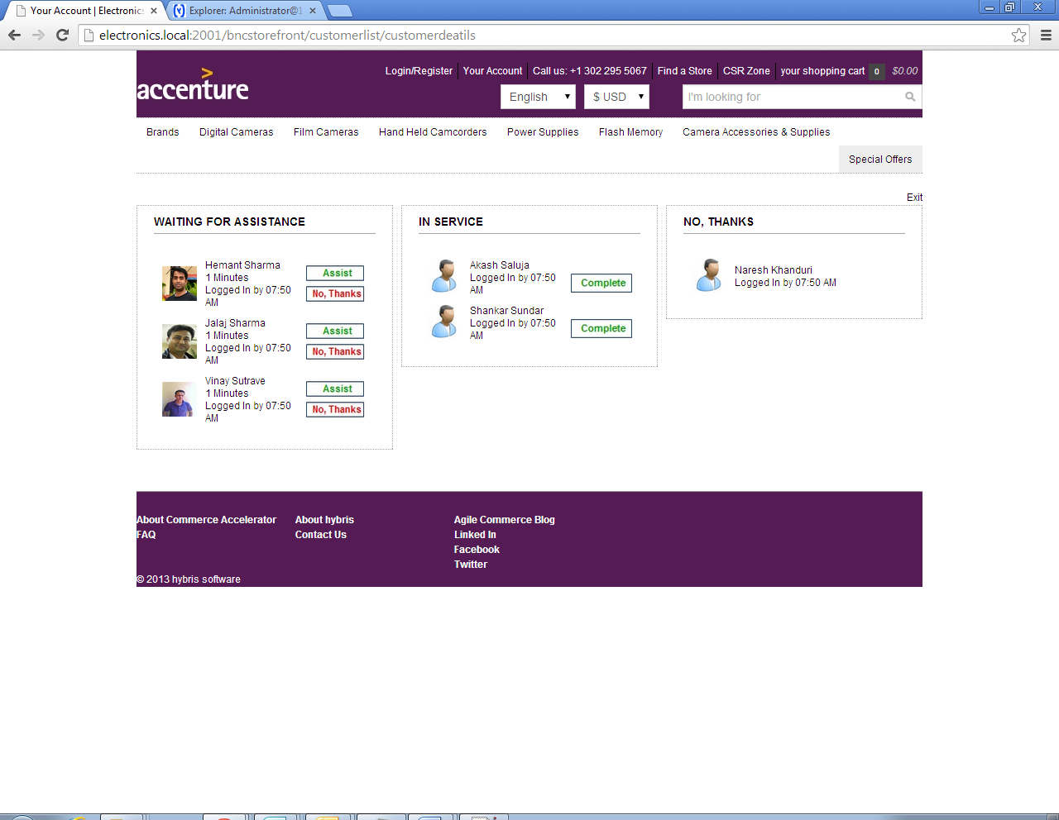

1. In case, there is a need to remove all the records from HMC. We need to follow below mentioned steps to clean the records:
2. Step 1:

Access HMC using url: [http://localhost:9001/hmc/hybris](http://10.168.138.15:2001/hmc/hybris)

Login: admin

Password: nimda

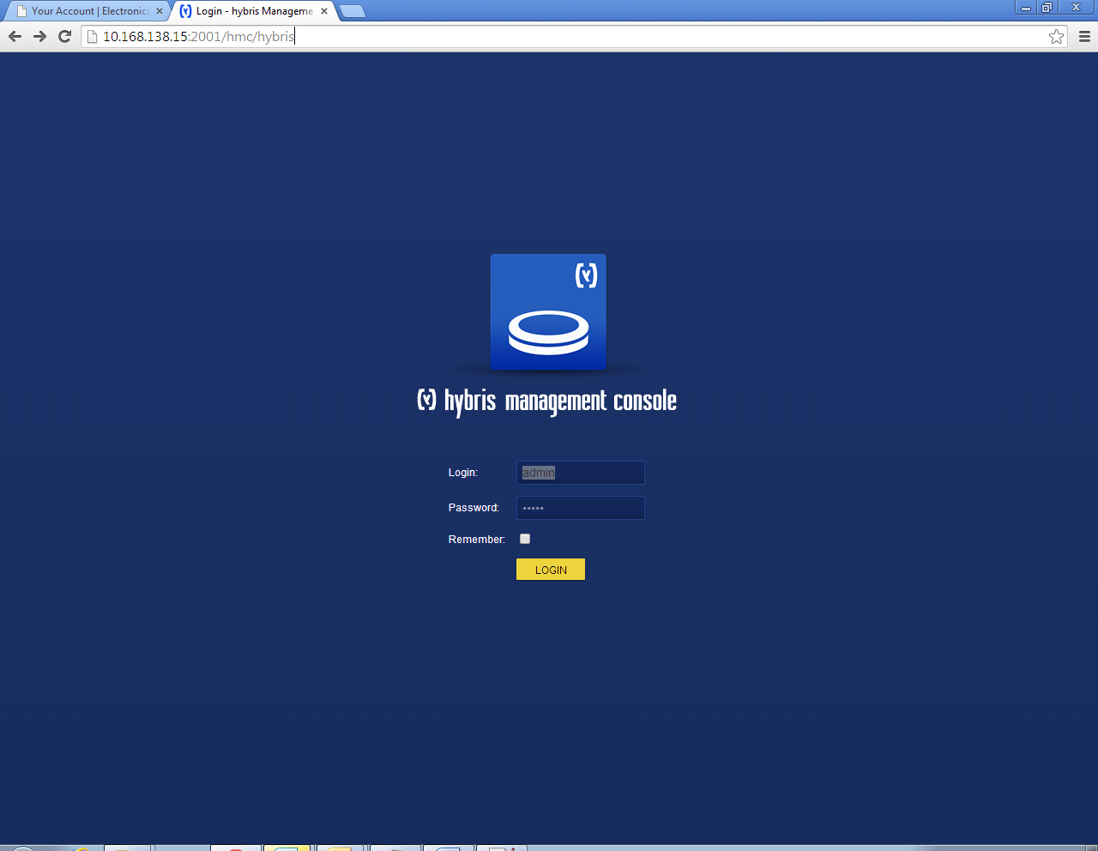

1. Step 2:

Click on System on left hand side navigation menu and click on “Types”

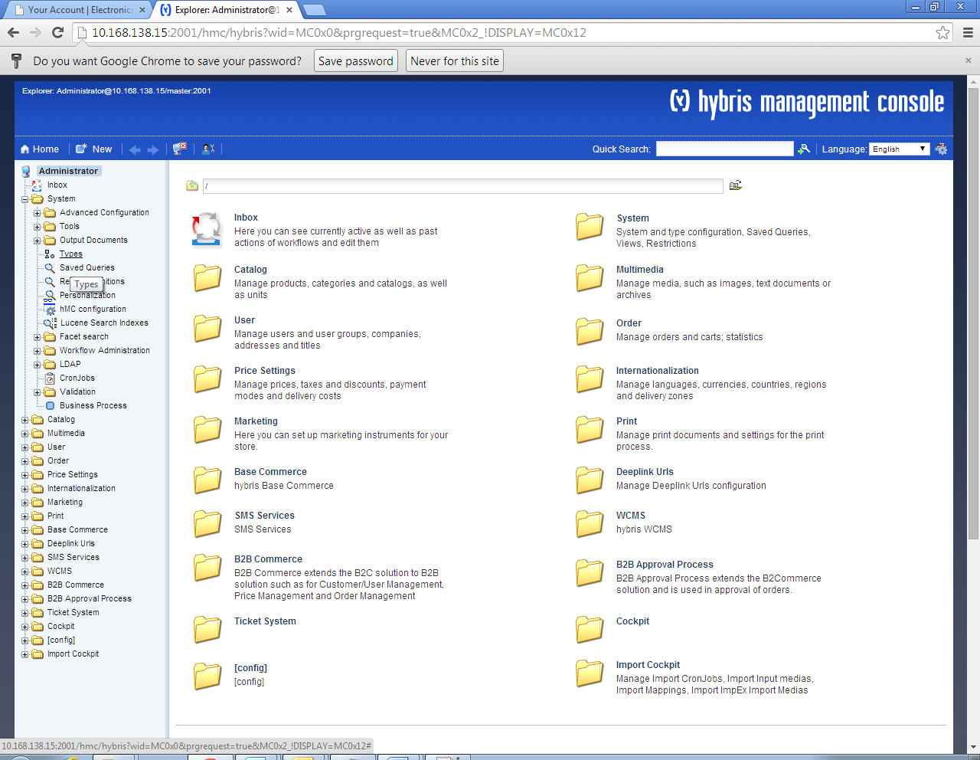

Following window will open:

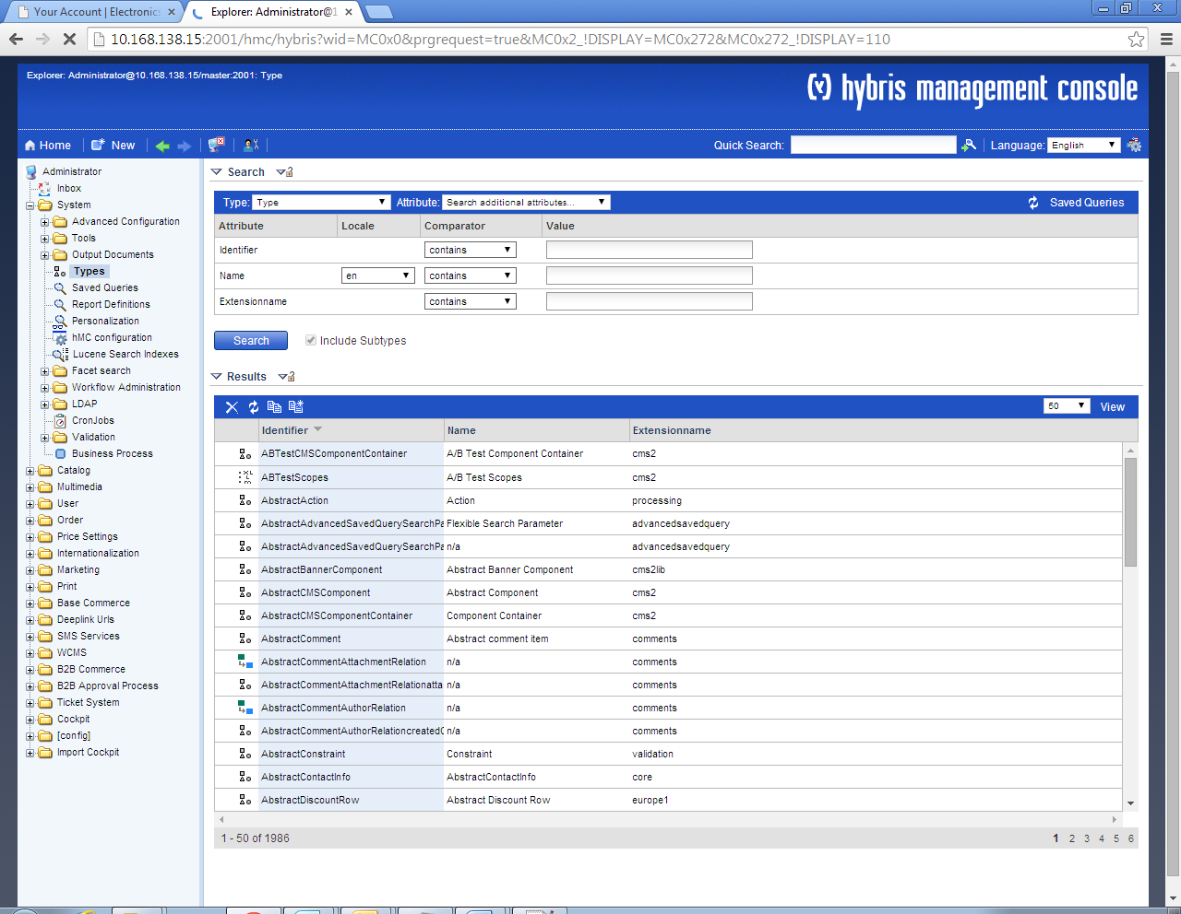

1. Step 3:

Now in search section, enter “CSRCustomerDetails” under Identifier text field and click on Search button. This will open following window:

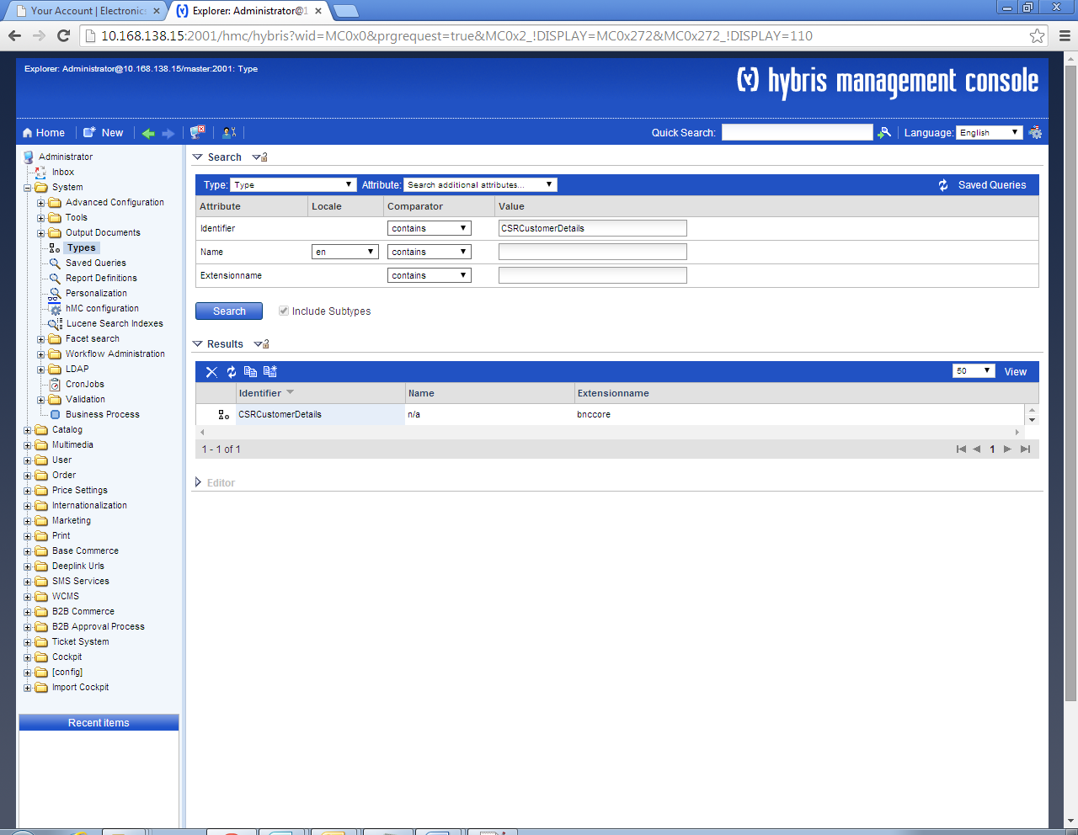

1. Step 4:

Open the editor and this will open following screen:

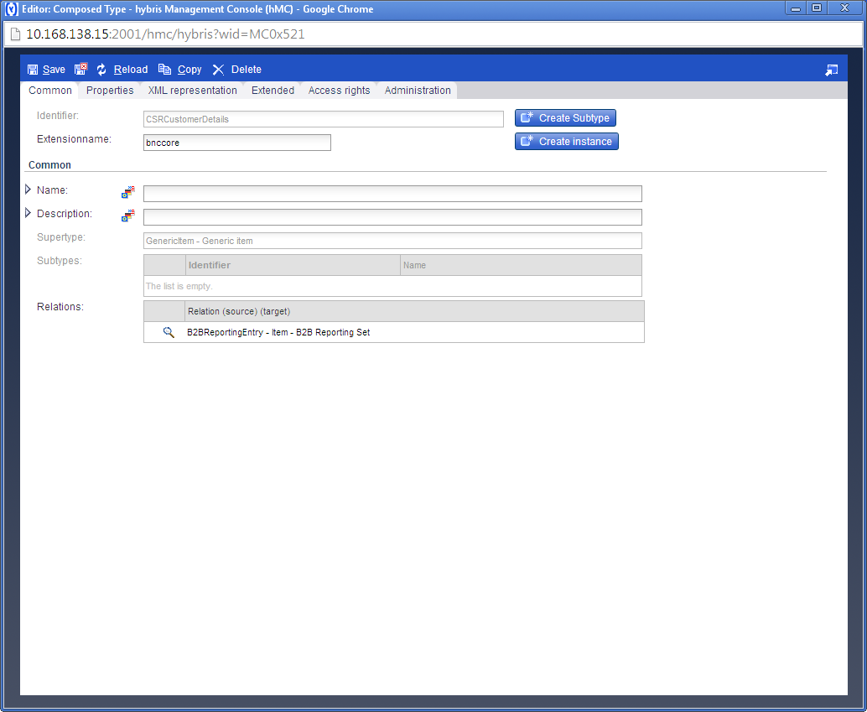

1. Step 5:

Now click on Open Organizer button on the extreme right corner. This will open following screen:

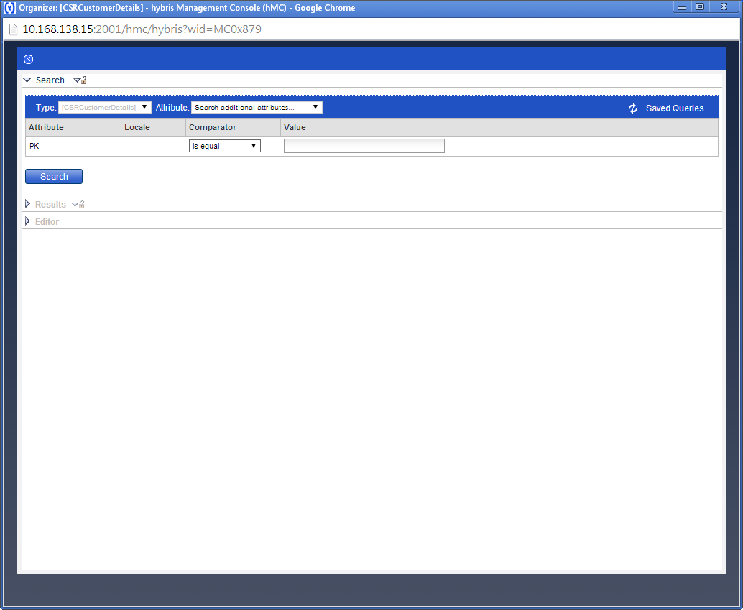

1. Step 6:

Click on Search button. This will list down all the CSRCustomerDetails records present in the system.

1. Step 7:

You can open any record to see the details. In case all the records need to be deleted, you can select all the records, right click and Remove.

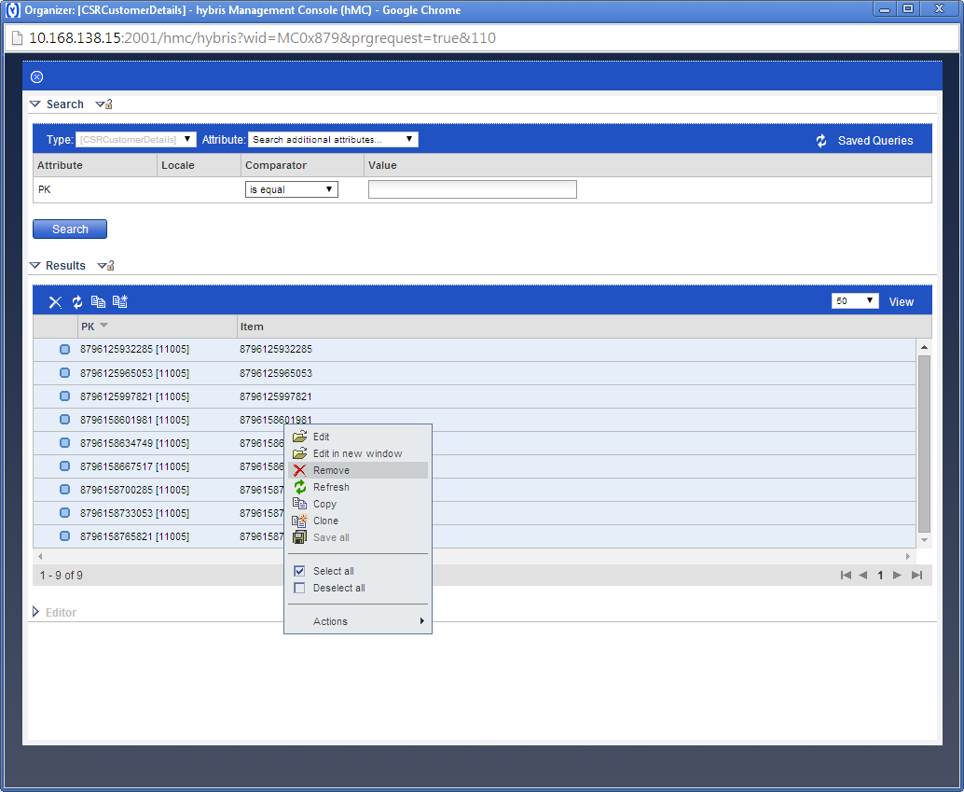

1. Step 8:

This action will remove all the records.

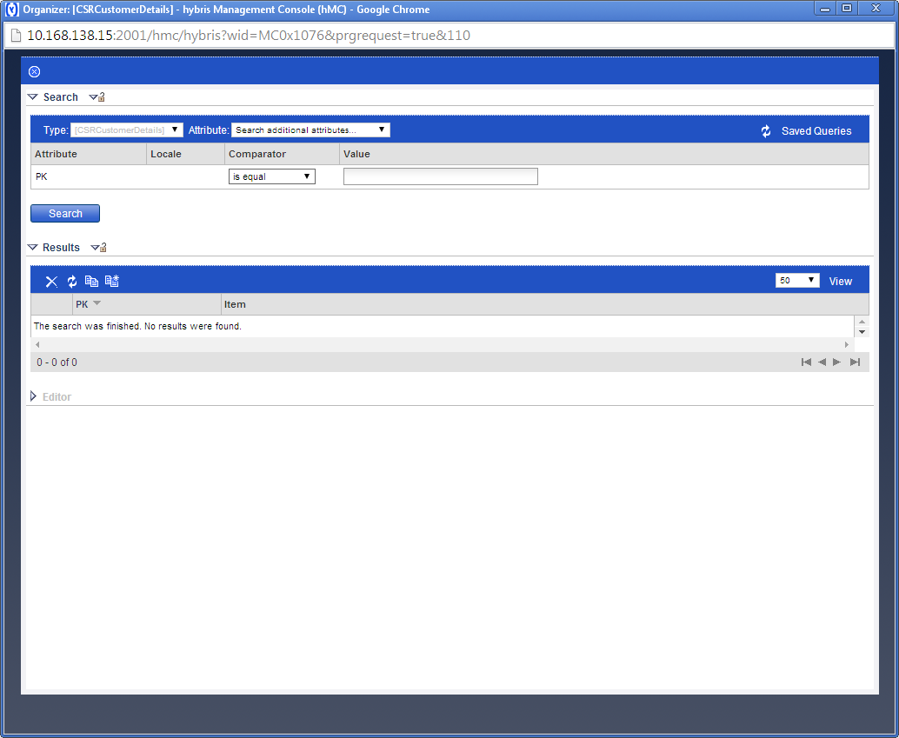

Now there will be no records present on the CSR Zone.

